SWT 12031: Practical for Object oriented Program

Department of Information and Communication Technology
Faculty of Technology
Lab sheet :04
Reg. Number: SEU/IS/20/ICT/084
Academic Year :2020/2021
Date: 2023.02.07
Practical No :04

Exercise 01:
- Create a class called ICT. Within this class, a. Define two variables namely regno and indexno.
- Initialize regno to “SEU/IS/20/ICT/003” and indexno to “ICT 150”.
- Create an object exam
- Access the objects through the reference variable.

public class ICT{

String regno ="SEU/IS/20/ICT/003";
String indexno ="ICT 150";

public static void main (String []args){

ICT exam =new ICT();

System.out.println("Reg.NO-"+exam.regno);
System.out.println("Indexno-"+exam.indexno);

}
}

Output:
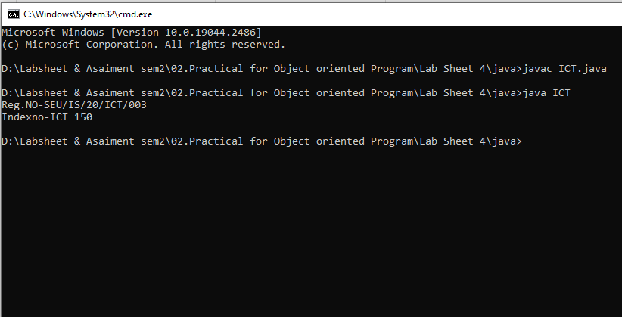

2. Modify the above program to bring the main method inside a separate class called Student.
a. Create an object john.
b. Access the objects through the reference variable
public class ICT{

String regno ="SEU/IS/20/ICT/003";
String indexno ="ICT 150";
}

class Students{

public static void main (String []args){

ICT john =new ICT();

System.out.println(john.regno);
System.out.println(john.indexno);
}
}

Output:
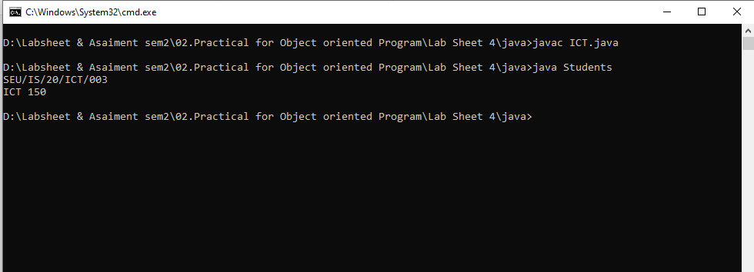

3. Modify question 2 as per the following instructions:
a. Create a method called insertStudentRecord() inside the Student class to initialize the regno and indexno.
b. Create another method displayStudentDetails() inside Student class to display the student details.
c. Create another object mich inside Student.
d. Call the method insertStudentRecord() to enter student data and displayStudentDetails() method to display the details of the Student

import java.util.Scanner;

public class ICT{

String regno ;
String indexno ;
}

class Students{

String regno ;
String indexno ;
ICT student =new ICT();

void insertStudentRecord(){

Scanner myObj = new Scanner(System.in);

System.out.print("Enter Student REG.Number:-");
regno = myObj.nextLine();

System.out.print("Enter Student indexno:-");
indexno = myObj.nextLine();

student.regno = regno;
student.indexno =indexno;
}
void displayStudentDetails(){

System.out.println("Student REG.Number:-"+student.regno);
System.out.println("Students Index No:"+student.indexno);
}

public static void main (String []args){

Students mich = new Students();

mich.insertStudentRecord();

System.out.println("");
System.out.println("");

mich.displayStudentDetails();

}
}

Output:

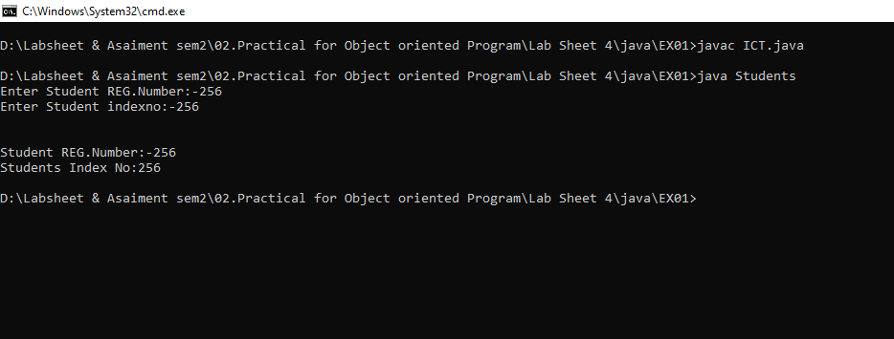

Exercise 02:
1. Create a class called StateBank. Within the class,
a. Create the variables bankid, bankname and banksalary (salary is a float value).
b. Create a method called insertBankDetails() to enter bank data.
c. Next, creae another method displayBankDetails () to display the bank details.

import java.util.Scanner;

class StateBank{
int bankid;
String bankname;
float banksalary;

void insertBankDetails(){
Scanner scanner = new Scanner(System.in);

System.out.print("Enter Bank ID:-");
bankid =scanner.nextInt();
System.out.print("Enter Bank Name:-");
bankname =scanner.nextLine();
System.out.print("Enter Bank salary:-");
banksalary =scanner.nextFloat();
}

void displayBankDetails (){

System.out.println("Bank ID :-"+bankid);
System.out.println("Bank Name :-"+bankname);
System.out.println("Bank Salary:-"+banksalary);

}
}

Output:
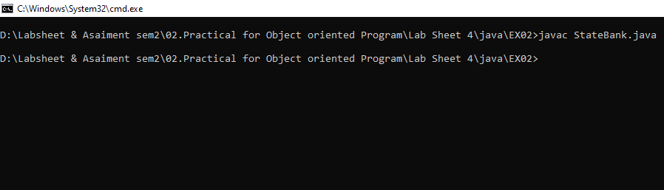

2. Within the same program, create another class PrivateBank with the main method.
a. Here, create three instances, pb1, pb2 and pb3.
b. Call the method insertPbBankDetails () to enter PrivateBank data and displayPbBankDetails() method to display the PrivateBank details.

Exercise 03:
1. Create a class called Rectangle. Within the class,
I. Create the variables length and width.
II. Create a method called insert() to enter rectangle details.
III. Next, creae another method calculateArea() to calculate the area of
the given rectangle.
• Within the same program, create another class TestRectangle with the main method.
I. Here, create two instances, rect1 and rect2.
II. Call the method insert() to enter length and width values of rectangle and calculateArea() method to display the area of the rectangles
import java.util.Scanner;

public class Rectangle{

int length;
int width;

void insert(){

Scanner scanner = new Scanner(System.in);

System.out.print("Enter You length:");
length =scanner.nextInt();

System.out.print("Enter You width:");
width =scanner.nextInt();

}

static int calculateArea(int length,int width){
return length*width;
}

}

class TestRectangle{

public static void main(String[] args) {

Rectangle rect1 = new Rectangle();

rect1.insert();
System.out.println("calculateArea is "+rect1.calculateArea(rect1.length,rect1.width));

Rectangle rect2 = new Rectangle();
rect2.insert();
System.out.println("calculateArea is "+rect2.calculateArea(rect2.length,rect2.width));
}
}

Output:
